**Assignment weeks 9, 10 and 11**

*To answer all the questions below, you must use Stata (and, specifically, DASP, if requested). Be concise and clear in your answers.*

*The assignment is divided into three exercises (the points assigned to each exercise are indicated next to each exercise). Please answer directly in this file after each question and please attach the *.do file (do-file) that you generated. Rename both files as: “Assignment weeks 9-10-11 - Name, Surname”. Please submit this completed file and the *.do through the virtual drop box (boîte de dépôt) in the course portal, no later than Tuesday, April 13 11:59 p.m. (*[***Québec time***](https://www.timeanddate.com/worldclock/converter.html?iso=20190410T035900&p1=189)*).*

# Exercise 1 (4.5%):

Assume that the population is composed of six individuals. The scores of each of the three dimensions of well-being are reported in the table below.

|  |  |  |  |
| --- | --- | --- | --- |
|  | $$w_{1}$$ | $$w_{2}$$ | $$w_{3}$$ |
| Individual 1 | 2 | 10 | 6 |
| Individual 2 | 4 | 6 | 0 |
| Individual 3 | 8 | 8 | 12 |
| Individual 4 | 6 | 6 | 8 |
| Individual 5 | 14 | 10 | 4 |
| Individual 6 | 12 | 8 | 6 |

Assume that the poverty threshold of each of the three dimensions is 7. Perform the following computations with Stata.

* 1. Using the union approach, estimate the proportion of poor individuals. Redo the estimation using the appropriate DASP command.

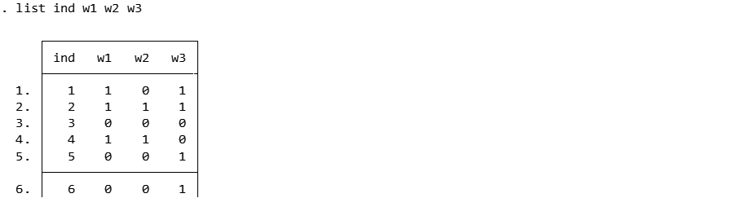

Individuals 1,2,4,5 and 6 are poor, i.e. 5/6 or around 83.3 percent of the individuals are poor. The union head count index for the population= 0.833. Around 83 percent of the population are multidimentionally poor as they are deprived in one or more dimensions.

* 1. Using the intersection approach, estimate the proportion of poor individuals. Redo the estimation using the appropriate DASP command.

Only one individual is poor where he/she is deprived of all dimensions of achievement, ie. 1/6 of the population is poor.

The intersection headcount index=0.167. 16.7 percent of the population shows deprivation in all dimensions.

* 1. Which approach is more sensitive to the increase in individual multiple deprivations?

Depending on the intial condition where the individual is located, the sensitivity of approaches may differ. If an individual is initially non poor, a deprivation in one dimension will make him/her poor according to the union approach. But if the individual is initially poor where he/she is not deprived in at least one dimension, then an increase in deprivation will make that person poor according to intersection approach, in this case no change is observed in union poor head count. So for individuals who are already poor, the intersection approach is sensitive to an increase in deprivation.

* 1. Estimate the Alkire and Foster (2007) index MPI( $α=0)$ when the dimensional cut-off is equal to 2 (the poor are those with two or three dimensions of deprivation).

The adjusted headcount index M0=0.389 .It simultaneously takes into account the incidence (H) and the breadth (A) of simultaneous deprivations.

* 1. Now estimate the same indices using the appropriate DASP command. Discuss your findings.

The adjusted headcount ratio (M0)=H*A, where H is the percentage of people that are poor and A is average deprevation share among the poor . H is 0.5 and the adjusted headcount Mo =0.389.

* 1. Assume that the government has 12$ and can target one dimension with a universal transfer. Which targeted dimension would most reduce the union index, and the intersection index? Discuss your findings.

Intervention on W3 sector reduces the union index most. Intervention on W1or W2 dimensions will not bring anyone out of poverty using the union approach.

The impact of intervention in any dimensions (W1 W2 W3) is the same in reducing the intersection index. Interventions in either of the dimensions have the same effect on the intersection index.

Exercise 2 (4%):

For the case of tri-dimensional well-being dimension, the Bourguignon and Chakravarty (2003) poverty index (henceforth the BC index) is defined as follows:

$${MDP}_{BC}=\frac{1}{H}\sum_{h=1}^{h}{π\text{(}w_{h}\text{; z) }}$$

Where $π\text{(}x_{h}\text{; z)}$ is the contribution of the individual $h$ to the total poverty:

$π\text{(}x_{h}\text{; z)=}{\left[β_{1}g_{h,1}^{ρ}+β_{2}g_{h,2 }^{ρ}+β_{3}g_{h,3}^{ρ})\right]}^{\frac{a}{ρ}}$*and $g_{h,i}=\frac{{\left(z_{i}-w_{h,i}\right)}_{+}}{z_{i}}$*

Using the data of exercise 1,

* 1. Estimate the Bourguignon and Chakravarty (2003) poverty index when $β_{i}=\frac{1}{3} ∀ i, { z}_{i}=7 ∀ i, α=1 and ρ=1$.

The MDI_BC Index = 0.1824

* 1. Redo the estimation using the appropriate DASP command.

The BC index=0.182

* 1. Generate three new variables (nw_*) wherein individuals equalize their well-being dimensions (example: gen nw_1 = (w_1+ w_2+w_3)/3) (i.e. For instance, individual 1 has 2, 10, 6 in the three dimensions respectively. After the equalisation, we will have: 6, 6, 6.). Then, using DASP, re-estimate the BC index with the new vectors of well-being. Explain the direction of the change in the BC index.

The BC index=0.159 Equalizing wellbeing dimensions lead to reduction of overall poverty.

# Exercise 3 (4%):

The data file ***Canada_1996_2005_random_sample_2*** is a randomly drawn sample of 100 000 observations. It contains information on net and gross incomes, taxes and transfers.

* 1. Using the observations from 2005, estimate the expected marginal tax, benefit and net income rates for a range of gross incomes between 1000 and 31000$ (hints: use the DASP ***cnpe*** command with the option: type(dnp)), and briefly discuss your results.

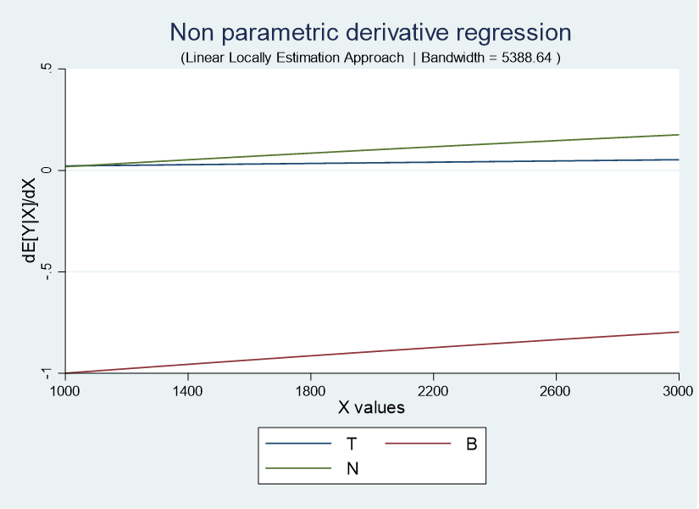

Marginal tax, benefit and income are increasing with gross income though at different rates. Marginal benefit increases at a higher rate than tax, hence increasing net income.

* 1. Estimate the redistributive impact on the Gini inequality index for 1999, 2002 and 2005 (hints: use the Stata commands preserve/restore to preserve the data after using the Stata command “keep if year==…”). Discuss your results.

The impact of the tax policy on inequality is shown by differences in gini inequality indices of gross incomes (pre tax incomes) and net incomes (post tax income) in different years. Tax policy was not inequality reducing in the case of net income where as its effect is netral in the case of gross income.

* 1. Estimate the Kakwani progressivity index per year using the DASP command ***iprog*** (hints: use the option gobs(year)), and briefly discuss your results.

gobs | Estimate STE LB UB

----------------+----------------------------------------------------------------

1993 | 0.061372 0.003533 0.054447 0.068297

1994 | 0.075898 0.003858 0.068335 0.083462

1996 | 0.095611 0.003406 0.088934 0.102287

1997 | 0.089836 0.005535 0.078985 0.100687

1998 | 0.101021 0.004634 0.091938 0.110104

1999 | 0.115967 0.004124 0.107883 0.124051

2000 | 0.105970 0.003623 0.098869 0.113071

2002 | 0.111361 0.005013 0.101536 0.121187

2003 | 0.111909 0.003289 0.105462 0.118356

2004 | 0.113497 0.003507 0.106623 0.120371

2005 | 0.124771 0.003457 0.117994 0.131548

The indices for all the years are positive indicating that the tax system was progressive during the periods. In addition, the indices increase through the years i.e the tax system got more progressive.

* 1. Using the observations from 2005, check the TR progressivity condition for the tax T by using the DASP command ***cprog***.



If the difference between the lorenz curve of gross income and concentration curve of tax is greater than zero in all the percentiles within the range of 0 and 1, both inclusive, then the tax system is tax progressive. The tax system is TR progressive as the lorenze curve of gross income looks to be above the concentration curve of tax for all percentiles.

* 1. In which province was inequality on gross incomes the highest in 2005? In which province was the Kakwani tax progressivity index the highest in 2005?

In 2005 inequality was the highest in the province of Newfoundland.

The highest Kakwani tax progressivity index in 2005 was in British_Colombia.